# **EDUNET FOUNDATION-Class Exercise Notebook**

Lab 3 - GitHub Commands

With Git, you record local changes to your code using a *command-line* tool, called the “Git Shell” (you can use Git in other command-line tools — Refer to Git Shell through the following sections). Command-line lets you enter commands to view, change, and manage files and folders in a simple terminal, instead of using a graphical user interface (GUI). If you have not used command-line before, don’t worry, once you get started, it is incredibly straightforward.

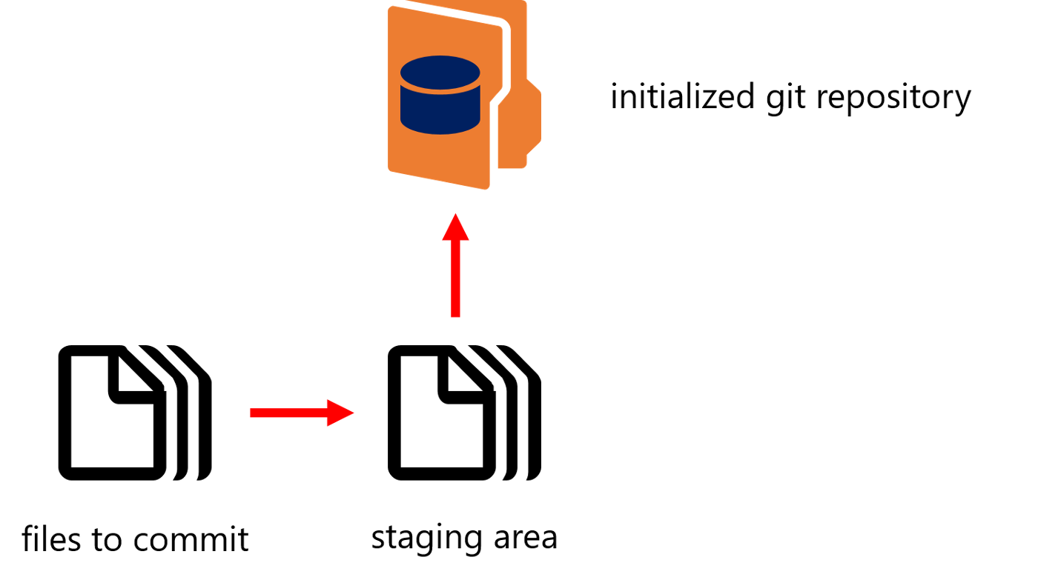

Essentially, when using Git, you make changes to your code files as you normally would during the development process. When you have completed a coding milestone, or want to snapshot certain changes, you add the files you changed to a staging area and then commit them to the version history of your project (repository) using Git. Below, you’ll learn about the Git commands you use for those steps.

**Terminal Commands**

While using Git on the command line, chances are you will also use some basic terminal commands while going through your project and system files / folders, including:

* **pwd**- check where you are in the current file system
* **ls** - list files in the current directory (folder)
* **cd [directory-name]** - moves to the given directory name or path
* **mkdir [directory-name]** - makes a new directory with the given name

**Creating Repositories**

When you wish to utilize Git for a project, the first command you must do is *git init*, with the name of your project:

**git init [project-name]**

You run this command on the Git Shell command-line in the main *directory*(folder) of your project, which you can navigate to in the Shell using the commands listed above. Once you run this command, Git creates a hidden .git file inside the main directory of your project. This file tracks the version history of your project and is what turns the project into a Git *repository*, enabling you to run Git commands on it.

**Making Changes**

* **git add [file]** or**git add \***

Once you make changes to your files and choose to snapshot them to your project’s version history, you have to add them to the staging area with *git add*, by file name, or by including all of the files in your current folder using *git add \**.

* **git commit -m “[message]”**

To finally commit the changes, you made to your files from the staging area to your repository’s version history, you need to run *git commit* with a descriptive message of what changes you made.

* **git status**

If at any point, you wish to view a summary of the files you have changed and not yet committed, simply run git status in your project’s repository on the Git Shell command-line.

**How It Works**

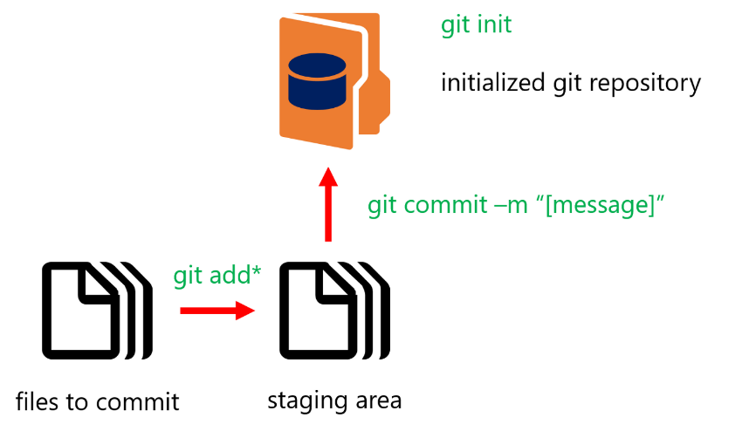

GitHub Workflow

Now, with the basic Git commands in place, you can utilize Git to snapshot the version history of your project. Simply initialize a new repository by running *git init* in your project’s main directory. Using *git add \**, or *git add* with specific file names, you add your changes to the staging area. Finally, using *git commit*, you can add your changes to the repository’s version history.

1. Open Anaconda Command Prompt and install git library

pip install git

1. Create a directory with two random .txt files. Place any piece of text in those files.

Configure the access of github profile on local github library

git config --global user.name username

git config --global user.email useremail

** Place your github login username and email information.

1. Change the folder to as current working directory. And run git init code

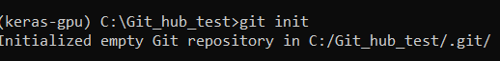

1. Git status shows files are untracked

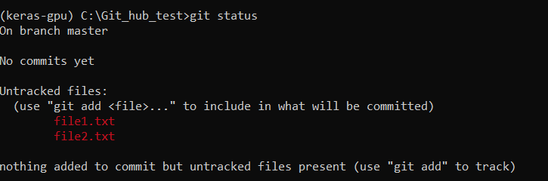

1. Add file1.txt to stage and check git status

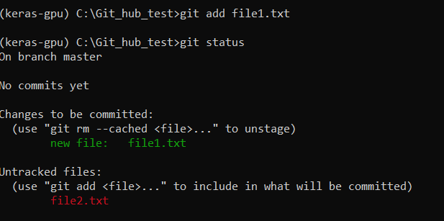

1. Now add another file2.txt to staging stage and check git status

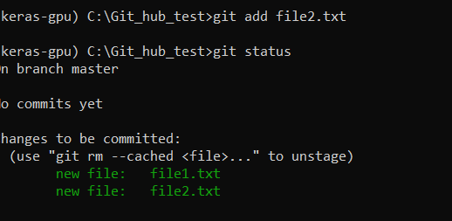

1. Commit the traced file using git commit command. You can also mention the commit message.

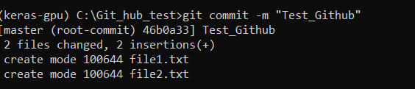

1. Add the address of repository to where you test files are to be uploaded.

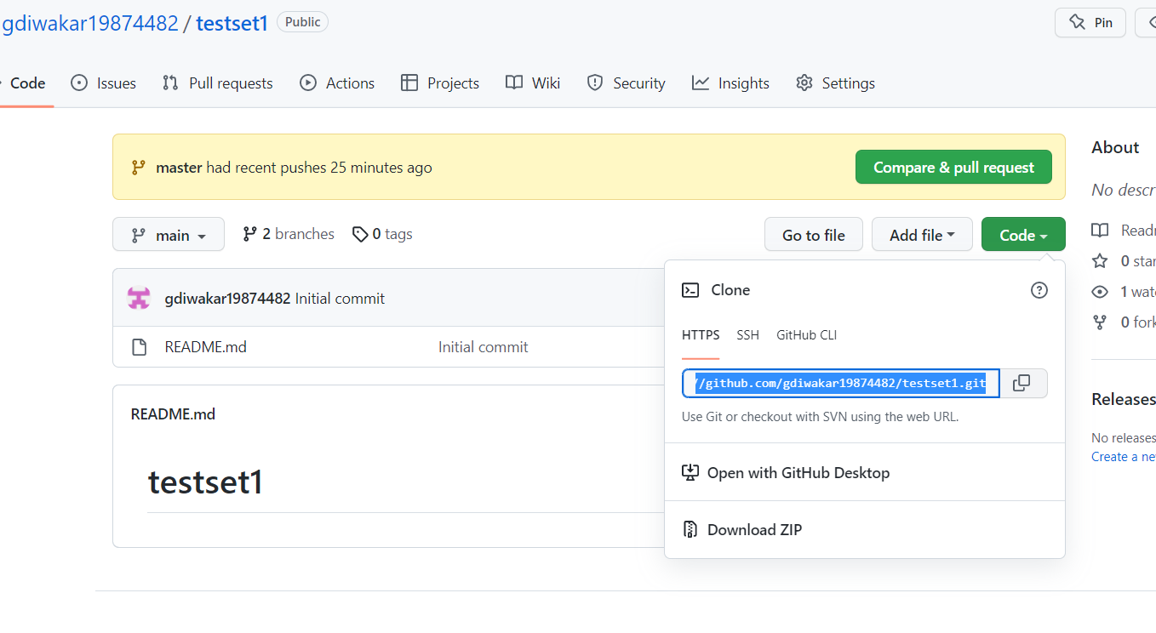



1. Upload your local repository to github using git push command

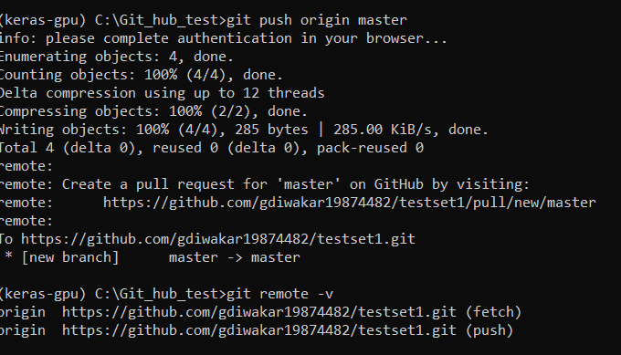

**Note: GUI window will request for read/ write access.

1. You will observe and conclude that your local repository gets uploaded to github repository

